

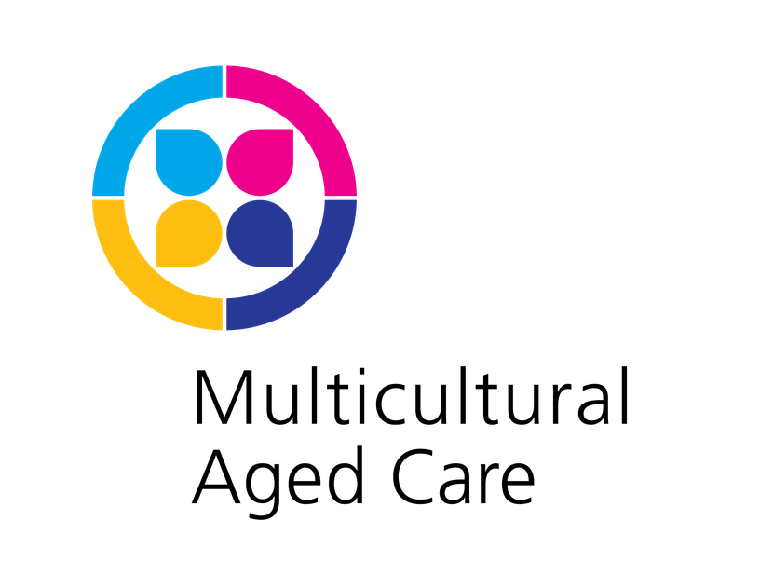

Grief Resources - Multicultural Aged Care Library

Callanan, M. & Kelley, P. (2012). Final gifts: understanding the special awareness, needs, and communications of the dying. Simon & Schuster Paperbacks

Firth, P., Luff, G. & Oliviere, D. (Eds.), (2005). Loss, change and bereavement in palliative care. Open University Press

Hassan, J. (2003). A house next door to trauma: learning from Holocaust survivors how to respond to atrocity. Jessica Kingsley Publishers

Hunt, L., Marshall, M. & Rowlings, C. (Eds.), (1997). Past trauma in late life: European perspectives on therapeutic work with older people. Jessica Kingsley Publishers

Irish, D.P., Lundquist, K.F. & Jenkins Nelsen, V. (Eds.), (1993). Ethnic variations in dying, death, and grief: diversity in universality. Routledge

Katafiasz, K. (Ed.), (1993). Grief therapy. Abbey Press

Kellehear, A. & Ritchie, D. (Eds.), (2003). Seven dying Australians. Innovative Resources.

Kissane, D.W. & Bloch, S. (2002). Family focused grief therapy: a model of family-centered care during palliative care and bereavement. Open University Press

Mackinlay, E. (2006). Spiritual growth and care in the fourth age of life. Jessica Kingsley

Merienne, R. (2014). Tough…Tough times…Tough decisions: easing the transition to aged care for all the family. Inspiring Publishers

Roger, E. J. (Ed.), (2007). The art of grief: the use of expressive arts in a grief support group. Routledge

